|  |
| --- |
| **Transparent quartz crystals** |

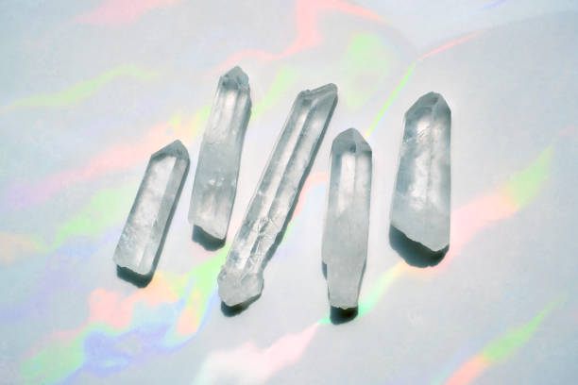

**Color**: Transparent quartz crystals are typically clear, although they may occasionally have slight color variations, ranging from smoky hues to faint tinges of other colors. When perfectly clear, they are often referred to as **"clear quartz"** or **"rock crystal."**

**Shape**: They naturally form in **hexagonal crystals**. They can appear as pointy, prism-like structures with distinct edges or as clusters of smaller crystals. The shape can vary depending on the environment in which they form.

**Transparency**: Quartz crystals can range from semi-transparent to completely transparent, with the clearest ones being the most valuable in jewelry and decorative uses.